Parent tutorial for adding ‘All about me information’
- Log in to your Tapestry account (if you need your account activation link resent please let Lindsey or a member of the Pre-school Team know and we will be happy to reset for you.)
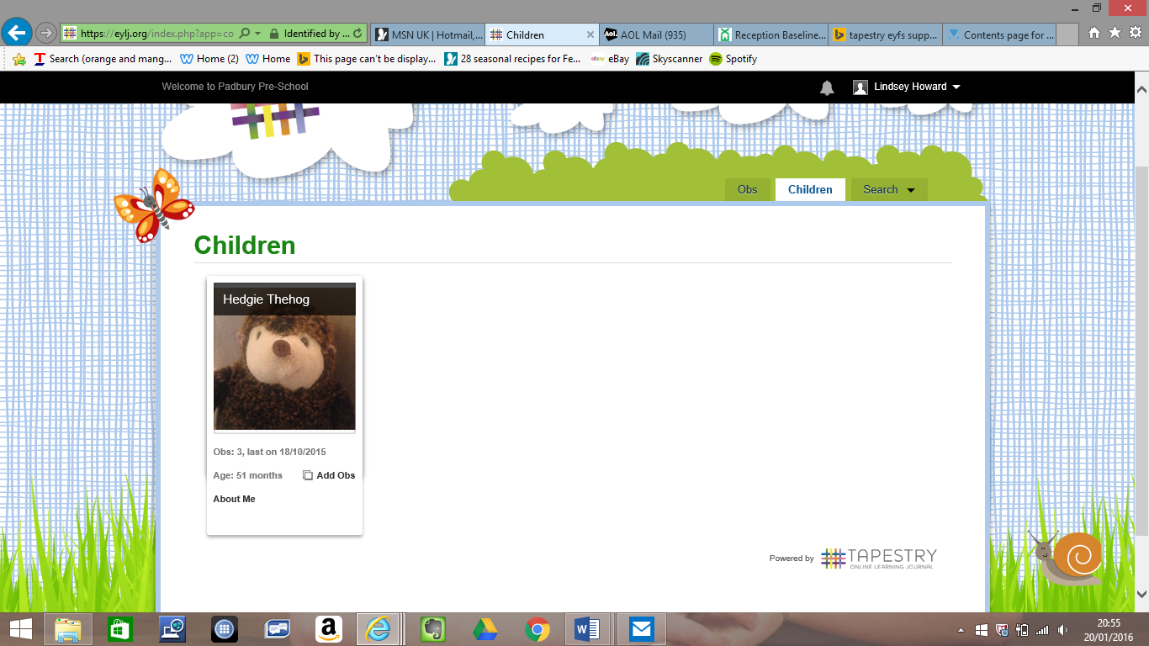
- Click on tab ‘Children’ (see image below), then click on ‘about me’ (bottom left of child’s profile box.

- Click on ‘Edit all about me’ and complete the questions by clicking and typing into the boxes. Then click on save at regular intervals whilst completing and again when you have finished.
